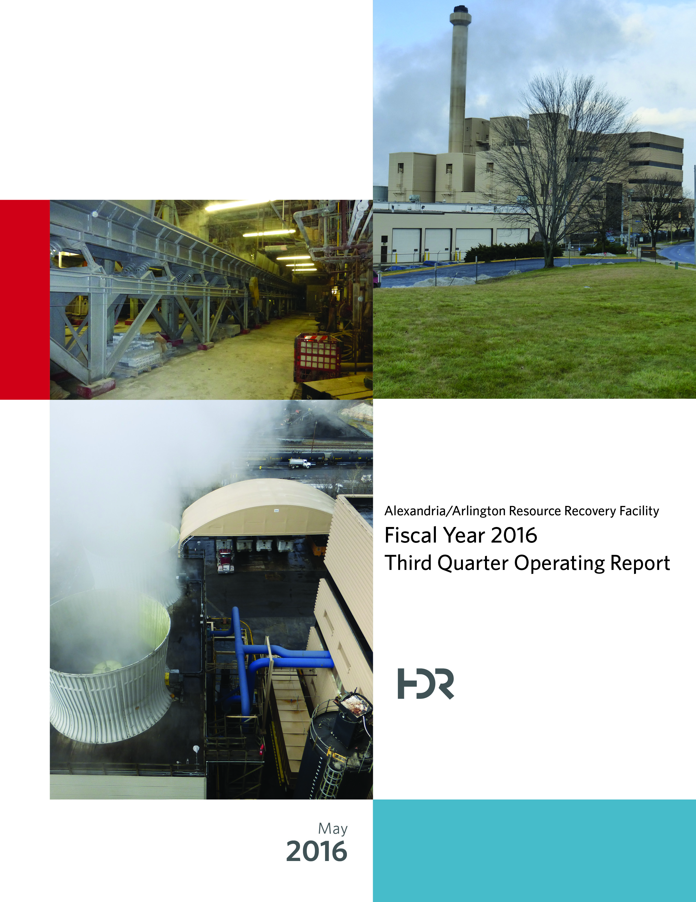

Table of Contents

Section No. Page No.

1.0 Purpose of Report 4

2.0 Executive Summary 4

3.0 Facility Inspection and Records Review 6

4.0 Facility Performance 9

4.1 Utility and Reagent Consumptions 23

4.2 Safety & Environmental Training 24

5.0 Facility Maintenance 25

5.1 Availability 28

5.2 Downtime Summary 30

5.3 Facility Housekeeping 31

6.0 Environmental 32

6.1 Nitrogen Oxide Emissions 32

6.2 Sulfur Dioxide Emissions 32

6.3 Carbon Monoxide Emissions 33

6.4 Opacity 33

6.5 Daily Emissions Data 33

6.6 Ash System Compliance 36

APPENDIX A FACILITY CEMS DATA 37

APPENDIX B PHOTOS 41

List of Tables

Table No. Page No.

Table 1: Summary of Audit Report Deficiencies 7

Table 2: Quarterly Performance Summaries 16

Table 3: Waste Delivery Classification 17

Table 4: Facility Utility and Reagent Consumptions 23

Table 5: Quarterly Facility Unit Availabilities 29

Table 6: Boiler Downtime – Q3FY16 30

Table 7: Turbine Generator Downtime – Q3FY16 30

Table 8: Facility Housekeeping Ratings – February 2016 31

Table 9: Stack Test Results through 2016 35

Table 10: Unit #1 Monthly Summary for Reportable Emissions Data 38

Table 11: Unit #2 Monthly Summary for Reportable Emissions Data 39

Table 12: Unit #3 Monthly Summary for Reportable Emissions Data 40

List of Charts

Chart No. Page No.

Chart 1: Tons of Waste Processed 9

Chart 2: Tons of Ash Produced per Ton of Waste Processed 10

Chart 3: Ferrous Recovery Rate 11

Chart 4: Steam Production 12

Chart 5: 12-Month Rolling Steam Production 13

Chart 6: Steam Production Rate 14

Chart 7: Calculated Waste Heating Value 15

Chart 8: Cumulative Total Waste Delivery 18

Chart 9: Gross Electrical Generation 18

Chart 10: Gross Conversion Rate 19

Chart 11: Net Conversion Rate 20

Chart 12: Net Conversion Rate 21

Chart 13: Gross Turbine Generator Conversion Rate 21

Chart 14: Net Turbine Generator Conversion Rate 22

Chart 15: Stack Test Results through 2016 34

Chart 16: Quarterly Ash Test Results 36

List of Figures

Figure No. Page No.

Figure 1: Holes in Ash Trailer (License Plate: 18 5294C) near ladder – New Deficiency 42

Figure 2: Vertical posts on Cooling Tower Stairs split (typical of 5) – New Deficiency 42

Figure 3: Drainage pipe along east wall of Tipping Floor damaged– New Deficiency 42

Figure 4: Curbing damaged (Typical of 2 locations), along Truck Entrance Road – New Deficiency 42

Figure 5: Chemical storage container deteriorated, north of Main Vibrating Pan, at ground elevation – New Deficiency 42

Figure 6: General Facility View from southwest 42

Figure 7: Ash Load-out Area - No issues observed 43

Figure 8: Ash Handling Screw Conveyor Troughs awaiting installation during outage 43

Figure 9: Main Vibrating Conveyor – No issues observed 43

Figure 10: Tipping Floor Entrance – No issues observed 43

Figure 11: Decommissioned Grapple 43

Figure 12: Scalehouse & Scales – No Issues Observed 43

Figure 13: New Radiation Detectors at Scales 44

Figure 14: Citizen’s Drop-off 44

Figure 15: Dolomitic Lime Silo 44

Figure 16: Ash Trailer Canopy 44

Figure 17: New Opacity Monitor 44

Figure 18: Baghouse Compartment Aisle – No issue observed 44

Figure 19: Deaerator – Work in Progress 45

Figure 20: Refuse Pit – Photo from north 45

Figure 21: New Crane Grapple – In service since December 2015 45

Figure 22: Turbine Generator Enclosure – No issues observed 45

Figure 23: Ferrous Magnet – Pan recently extended to improve recovery 45

Figure 24: General Facility View – Photo from north side parking lot 45

**Definition of Abbreviations & Acronyms**

|  |  |
| --- | --- |
| Abbreviation/Acronym | Definition |
| APC | Air Pollution Control |
| Apr | April |
| Aug | August |
| Avg | Average |
| Btu | British thermal unit |
| CAAI | Covanta Alexandria Arlington, Inc. |
| CEMS | Continuous Emissions Monitoring System |
| CO | Carbon Monoxide |
| Dec | December |
| ECOM | Emergency Communications |
| Feb | February |
| FMG | Facility Monitoring Group |
| FY | Fiscal Year |
| gal | Gallon |
| GAT | Guaranteed Annual Tonnage |
| HCl | Hydrochloric (Hydrogen Chlorides) |
| HDR | HDR Engineering Inc |
| ID | Induced Draft |
| Jan | January |
| Jul | July |
| Jun | June |
| klbs | Kilo-pounds (1,000 lbs) |
| kWhr | Kilowatt hours (1,000 watt-hours) |
| lbs | Pounds |
| LOA | Letter of Agreement |
| Mar | March |
| Max | Maximum |
| May | May |
| Min | Minimum |
| MSW | Municipal Solid Waste |
| MWhr | Megawatt hours |
| No | Number |
| NOV | Notice of Violation |
| Nov | November |
| NOx | Nitrogen Oxide |
| Oct | October |
| OSHA | Occupational Safety and Health Administration |
| PDS | Potomac Disposal Services |
| ppm | Parts per million |
| ppmdv | Parts per million dry volume |
| PSD | Prevention of Significant Deterioration |
| Q1 | First Quarter |
| Q2 | Second Quarter |
| Q3 | Third Quarter |
| Q4 | Fourth Quarter |
| RE | Reportable Exempt |
| RNE | Reportable Non-Exempt |
| SDA | Spray Dryer Absorber |
| Sep | September |
| SO2 | Sulfur Dioxide |
| TCLP | Toxicity Characteristic Leaching Procedure |
| VADEQ | Virginia Department of Environmental Quality |
| WL | Warning Letter |
| yr | Year |
| YTD | Year to date |

Alexandria/Arlington Waste-to-Energy Facility

Third Quarter Operating Report – Fiscal Year 2016

# Purpose of Report

HDR Engineering, Inc. (HDR) was authorized by the Facility Monitoring Group (FMG) to conduct quarterly inspections and provide quarterly reports regarding the operation and maintenance of the Covanta Alexandria/Arlington Waste-to-Energy Facility (Facility) for the 2016 calendar year. This report is prepared for the third quarter of the 2016 fiscal year and summarizes Facility operations between January 1, 2016 and March 31, 2016. This report identifies the fiscal year beginning on July 1, 2015 as FY16 and the quarter beginning on January 1, 2016 as Q3FY16.

This report is based upon HDR’s experience in the waste-to-energy industry, upon site observation visits and previous reports provided by HDR, and upon data provided by Covanta Alexandria / Arlington, Inc. (CAAI), the Facility owner and operator.

# Executive Summary

CAAI operated the Facility in an acceptable manner and in accordance with established waste-to-energy industry practices during Q3FY16. The operation of the Facility, maintenance, safety, and overall cleanliness continue to be above average. Environmental performance was excellent with no reportable environmental excursions throughout the quarter.

During Q3FY16, the Facility experienced two (2) instances of unscheduled downtime for the boilers totaling 19.6 hours, and one (1) instance of unscheduled downtime for Turbine Generator No. 2 totaling 10.5 hours. Beginning January 24, 2016, Boiler No. 2 experienced 135.5 hours of downtime for scheduled maintenance. Beginning February 27, 2016, Boiler No. 1 experienced 138.0 hours of downtime, and beginning March 5, 2016, Boiler No. 3 experienced 138.4 hours of downtime for scheduled maintenance. Beginning February 28, 2016, Turbine Generator No. 1 experienced 135.6 hours of downtime for scheduled maintenance. During Q3FY16, the boilers experienced four (4) instances of standby time totaling 130.5 hours, and Turbine Generator No. 1 experienced two (2) instances of standby time totaling 141.5 hours. Note that standby time isn’t factored into reported availability. A detailed listing of downtime is provided in Section 5.2 of this report.

Average waste processed during the quarter was 902 tons per day, or 92.5% of nominal facility capacity. Waste deliveries averaged 904.6 tons per day, which is 0.3% higher than the burn rate. The capacity utilization of 92.5% appears to be limited by permit restrictions, given the amount of standby time incurred during the quarter.

Performance trends for various measurements are presented in Section 4. In general, the Facility continues to demonstrate reasonable consistency in month to month performance throughout the most recent three-year period tracked for detailed comparisons.

During the quarter, MSW processed increased 0.3% from the corresponding quarter in FY15; steam production increased 1.0%, and electricity generated (gross) increased 1.2% from the corresponding quarter in FY15. The increase in steam generation was attributable to the increase (1.8%) in the calculated average waste heating value, as well as less downtime (6.3 fewer hours) experienced by the boilers. The increase in gross electrical generation in Q3FY16 as compared to Q3FY15 is attributable to the decrease in steam production, offset by more downtime (166 additional hours) experienced by the Turbine Generators. Also note that 2016 is a Leap Year and February 2016 had an additional day of operations, when compared to the prior 2 operating years, which positively biases processed tonnage, steam production, and electrical generation.

# Facility Inspection and Records Review

In February 2016, HDR met with the Facility management and other plant personnel to discuss Facility operations, and maintenance, acquire Facility data and reports, perform an independent visual inspection of the operating Facility, photograph areas of interest, and perform a review of recent Facility activity. This visit was coordinated with the scheduled FMG meeting. At the time of the inspection, HDR reviewed CAAI records, discussed performance issues with CAAI staff, and provided a verbal report and performance statistics at the FMG meeting. HDR maintains a running tabulation of the status of corrective actions and plant performance trends. CAAI provides the following documents for each month:

* Facility Monthly Operating Reports
* Monthly Continuous Emissions Monitoring System (CEMS) Reports

Table 1 summarizes maintenance, repair, and plant condition issues reported during this and prior audit reporting periods. An “A” indicates an issue of the highest priority and worthy of immediate attention. Such items are usually safety or operability issues. A “B” indicates that the issue needs to be dealt with as quickly as possible, but is not urgent. These items will usually result in a process improvement or will help avoid future “urgent” issues. A “C” indicates that the issue should be dealt with at the earliest convenience, but is not a priority issue. This category might include issues related to aesthetics, non-urgent maintenance, or housekeeping improvements which are not safety related.

Table 1: Summary of Audit Report Deficiencies

*A is highest priority & demands immediate attention: B needs attention, but is not urgent; C can be addressed at earliest opportunity & is not urgent.

| Item No. | Audit Report Deficiencies | Issue Reported | Priority* | HDR Recommendation | Status | Open / Closed |
| --- | --- | --- | --- | --- | --- | --- |
| 1 | Concrete to roadway drain at truck entrance damaged – exposing reinforcing bar | May 2014 | C | Repair damaged concrete | **Complete** | Closed |
| 2 | Corrosion on ceiling panels in Turbine Generator Enclosure | August 2014 | C | Sand, Prime, Paint and Preserve, and replace deteriorated panels as necessary | **HDR observed the corroded/deteriorated sections had been primed, but no panels were replaced. CAAI reports that it plans to replace panels in 1 to 2 years.** | Open |
| 3 | Corrosion on ceiling panels in Turbine Generator Enclosure (Alternate Location) | August 2014 | C | Sand, Prime, Paint and Preserve, and replace deteriorated panels as necessary | **HDR observed the corroded/deteriorated sections had been primed, but no panels were replaced. CAAI reports that it plans to replace panels in 1 to 2 years.** | Open |
| 4 | Deteriorated purlin east wall in Tipping Floor Enclosure | November 2014 | C | Replace deteriorated purlin | **CAAI reports that it will replace sections of the east wall of the Tipping Floor Enclosure as a 2016 Budget Item.** | Open |
| 5 | Damaged curbing northeast corner of Facility near Citizen’s Drop-off | November 2014 | C | Repair curbing | **Status Unchanged** | Open |
| 6 | Damaged curbing west side of Cooling Towers | November 2014 | C | Repair curbing | **Status Unchanged** | Open |
| 7 | Damaged curbing near Ash Trailer Parking Area | November 2014 | C | Repair curbing | **Status Unchanged** | Open |
| 8 | Panels on east wall in Charging Floor damaged | February 2015 | C | Replace damaged wall panels | **Status Unchanged** | Open |
| 9 | Induced Draft Fan No. 1 Lagging deteriorated, west side of CEMS Enclosure | May 2015 | C | Replace deteriorated Induced Draft Fan Lagging | **Status Unchanged** | Open |
| 10 | Pot hole, southwest corner of Ash Trailer Canopy | August 2015 | C | Repair road surface | **Status Unchanged** | Open |
| 11 | Ash Trailers (typical of 3) have a damaged top pressure-treated wood rail (2”x6”) | November 2015 | C | Contact ash hauling company and request repairs be made to ash trailers | **Status Unchanged** | Open |
| 12 | Ceiling panels corroded, above Condensate Make-up Tank – Painting Item | November 2015 | C | Conduct proper painting preservation measures | **Complete** | Closed |
| 13 | Pressure treated support split at bolt, on Cooling Tower Access Stairs | November 2015 | A | Inspect entire Cooling Tower Access Stairway and replace split supports as needed | **Complete** | Closed |
| 14 | Holes in Ash Trailer (License Plate: 18 5294C) near ladder – See Figure 1 (Appendix B) | February 2016 | C | Report to ash hauling company and assure proper repairs are made | **Status Unchanged** | Open |
| 15 | Vertical posts on Cooling Tower Stairs split (typical of 5) – See Figure 2 (Appendix B) | February 2016 | A | Replace vertical posts | **Status Unchanged** | Open |
| 16 | Drainage pipe along east wall of Tipping Floor damaged– See Figure 3 (Appendix B) | February 2016 | C | Repair drainage pipe | **Status Unchanged** | Open |
| 17 | Curbing damaged (Typical of 2 locations), along Truck Entrance Road – See Figure 4 (Appendix B) | February 2016 | C | Replace curbing | **Status Unchanged** | Open |
| 18 | Chemical storage container deteriorated, north of Main Vibrating Pan, at ground elevation – See Figure 5 (Appendix B) | February 2016 | A | Replace storage container | **Status Unchanged** | Open |

# Facility Performance

Monthly operating data provided by CAAI indicates that 82,085 tons of MSW were processed during Q3FY16, and a total of 82,317 tons of MSW including 2,284 tons of Special Handling Waste were received. Total ash production during the quarter was 16,867 tons, which represents 20.5% of the waste processed. The average uncorrected steam production rate for Q3FY16 was 3.01 tonssteam/tonwaste, which is higher (0.8%) than the corresponding quarter in FY15. The increase in this metric correlates with the increase (1.8%) in calculated average waste heating value that was experienced in Q3FY16, as compared to Q3FY15.

Chart 1: Tons of Waste Processed

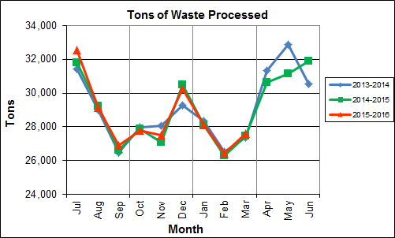

Chart 1 illustrates that Q3FY16 waste processed was slightly higher (0.3%) than the corresponding quarter, Q3FY15.

CAAI reported that 453 tipping floor/MSW internal inspections were conducted during the quarter and one (1) notice of violation (NOV) was issued to a hauler in February 2016 for unacceptable dumping on a Sunday during off hours.

Chart 2: Tons of Ash Produced per Ton of Waste Processed

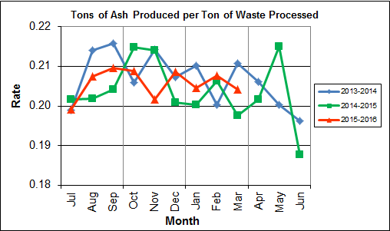

Chart 2 illustrates that the average ash production rate in Q3FY16 was higher (0.4%) at 20.5% of processed waste, compared to the corresponding quarter in FY15 when the rate was 20.1%. Ash production remains in the 20.0% to 21.0% range, as a result of the installation of the “semi-dry” ash discharger spray system in May 2012, and represents less moisture in the ash residue shipped to disposal.

Chart 3: Ferrous Recovery Rate

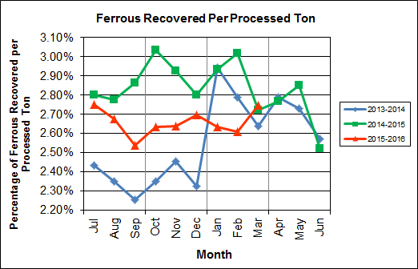

Chart 3 depicts the monthly ferrous metal recovery rate as a percentage of processed MSW tonnage. In Q3FY16, 2,187 tons of ferrous metals were recovered, which is 7.6% lower than the corresponding quarter in FY15 and equivalent to 2.7% of processed waste. CAAI reports that in recent months it was noted that the ferrous recovery rate had decreased and they replaced an end section of the vibrating pan which was worn due to wear from material getting caught between the pan and magnet. However, the metal recovery rate remains well below the rates experienced in the prior two (2) years during Q3. The reason for the substantial decrease remains unexplained.

**Chart 4: Steam Production**

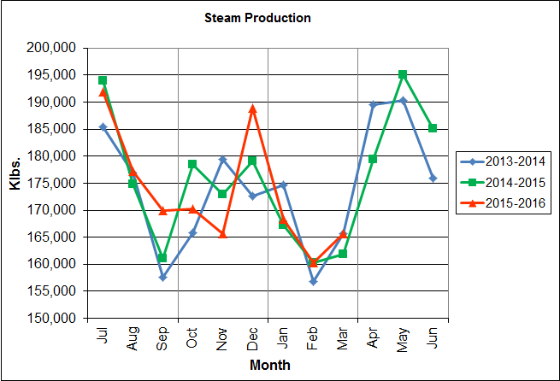

In Chart 4, the total steam production for Q3FY16 was 494,295 klbs., and 1.0% higher than the corresponding quarter in FY15. The increase in steam production is attributable to the increase (1.8%) in the calculated average waste heating value, paired with less downtime (6.3 fewer hours) experienced by the boilers, and an additional day of operations as a result of the Leap Year.

Chart 5: 12-Month Rolling Steam Production

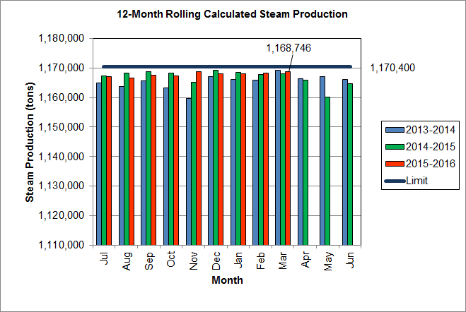

Chart 5 depicts the 12-month rolling steam production total for the period ending in March 2016. According to the Title V permit, the annual steam production for the Facility shall not exceed 1,170,400 tons on the basis of an average value of 3.34 lbs of steam per lb of MSW processed, calculated monthly as the sum of each consecutive 12 month period. The Facility was in compliance with the 12-month rolling steam production total every month in the quarter. The 12-month rolling total for steam production ending in March 2016 was 1,168,746 tons which is 99.9% of the limit. Chart 5 clearly shows that Facility throughput, and in turn, steam and electricity production are being throttled to stay ever so slightly below the steam production limit nearly every month.

Chart 6: Steam Production Rate

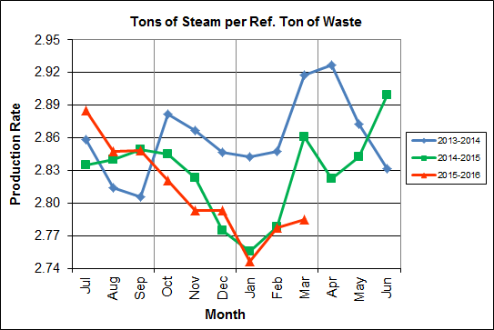

In Chart 6, the conversion of raw waste tonnages into “reference tons” is another way of analyzing steam production, and helps to determine whether changes are related to boiler performance or to fuel issues. “Reference tons” are adjusted to account for the calculated average fuel heating value, so that lower Btu fuel raw tonnages are adjusted upwards and vice versa. In Q3FY16, this metric tracked lower (1.0%) at 2.8 tonssteam/tonref, compared to the corresponding quarter in FY15.

Chart 7: Calculated Waste Heating Value

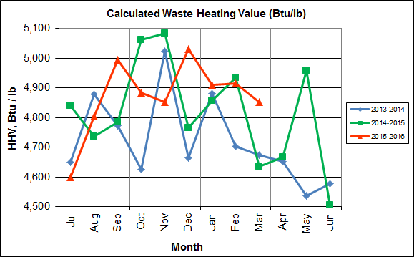

Chart 7 illustrates that Q3FY16 calculated average waste heating value was higher (1.8%) at 4,893 Btu/lb than the corresponding quarter Q3FY15, which averaged 4,808 Btu/lb.

Table 2: Quarterly Performance Summaries

|  |  |  |  |  |  |  |  |  |
| --- | --- | --- | --- | --- | --- | --- | --- | --- |
| Month | | Waste Processed (tons) | Waste Diverted  (tons) | Ash Shipped  (tons) | Special Handling (Supplemental)  (tons) | Ferrous Recovered  (tons) | Steam Produced (klbs) | Net Electrical Generation  (MWhr) |
| **Q3FY14** | **Quarterly Totals** | **82,214** | **0** | **17,036** | **699** | **2,296** | **497,215** | **34,952** |
| January-14 | 28,329 | 0 | 5,956 | 276 | 834 | 174,634 | 12,523 |
| February-14 | 26,537 | 0 | 5,314 | 192 | 740 | 156,865 | 11,037 |
| March-14 | 27,348 | 0 | 5,766 | 231 | 722 | 165,716 | 11,392 |
| **Q3FY15** | **Quarterly Totals** | **81,876** | **0** | **16,486** | **1,012** | **2,366** | **489,283** | **34,193** |
| January-15 | 28,114 | 0 | 5,632 | 389 | 825 | 167,202 | 11,777 |
| February-15 | 26,301 | 0 | 5,426 | 351 | 794 | 160,221 | 11,322 |
| March-15 | 27,461 | 0 | 5,428 | 272 | 747 | 161,860 | 11,094 |
| **Q3FY16** | **Quarterly Totals** | **82,085** | **0** | **16,867** | **2,284** | **2,187** | **494,295** | **34,595** |
| January-16 | 28,091 | 0 | 5,748 | 642 | 740 | 168,391 | 11,902 |
| February-16(1) | 26,414 | 0 | 5,487 | 850 | 689 | 160,228 | 11,192 |
| March-16 | 27,580 | 0 | 5,632 | 792 | 758 | 165,676 | 11,501 |
| **FY16 YTD Totals** | | **256,229** | **0** | **52,698** | **6,305** | **6,818** | **1,558,242** | **108,322** |
| **FY15 Totals** | | **348,686** | **0** | **71,019** | **5,413** | **9,864** | **2,109,442** | **145,085** |
| **FY14 Totals** | | **349,118** | **0** | **72,071** | **3,549** | **8,922** | **2,091,123** | **143,064** |

**Note(1): 2016 is a Leap Year and therefore February 2016 had 29 operating days**

Table 2 presents the production data provided to HDR by CAAI for Q3FY16 on both a monthly and quarterly basis. For purposes of comparison, data for Q3FY14 and Q3FY15 are also shown, as well as FY14, FY15 and FY16 YTD totals.

In comparing quarterly totals, the data shows:

* More waste was processed in Q3FY16 than Q3FY15 and less than Q3FY14
* More steam was generated in Q3FY16 than Q3FY15 and less than Q3FY14
* More electricity was generated in Q3FY16 than Q3FY15 and less than Q3FY14
* Substantially more supplemental waste was received in Q3FY16 than Q3FY15 and Q3FY14.

Please note that the total steam generation figures presented in Table 2 do not correlate with the annual steam production limit from the Facility Permit; such limits apply on a 12-month rolling average monthly basis, and not a fiscal year basis. It is also worth noting that the quantity of waste processed during Q3FY16 and FY16 continues to be limited by the steam production permit restrictions (refer to Chart 5).

Table 3: Waste Delivery Classification

|  |  |  |  |  |  |  |  |  |  |  |  |  |  |  |  |
| --- | --- | --- | --- | --- | --- | --- | --- | --- | --- | --- | --- | --- | --- | --- | --- |
|  |  | **Jul** | **Aug** | **Sep** | **Oct** | **Nov** | **Dec** | **Jan** | **Feb** | **Mar** | **Apr** | **May** | **Jun** | **Totals** | **% of Total** |
| **FY12** | **Jurisdiction Waste** | 18,112 | 20,021 | 19,304 | 17,796 | 17,523 | 17,211 | 16,202 | 14,952 | 17,430 | 18,338 | 20,138 | 18,361 | 215,381 | 61.89% |
| **Spot Waste tons** | 8,901 | 13,623 | 13,303 | 9,788 | 11,976 | 11,900 | 10,276 | 10,697 | 10,283 | 10,029 | 11,333 | 10,177 | 132,295 | 38.01% |
| **Supplemental Waste** | 10 | 10 | 34 | 15 | 15 | 21 | 12 | 22 | 15 | 23 | 68 | 91 | 336 | 0.10% |
| **MSW Totals** | **27,023** | **33,654** | **32,641** | **27,599** | **29,514** | **29,132** | **26,490** | **25,672** | **27,729** | **28,390** | **31,539** | **28,629** | **348,012** | **100.00%** |
|  |  |  |  |  |  |  |  |  |  |  |  |  |  |  |  |
| **FY13** | **Jurisdiction Waste** | 19,413 | 18,357 | 16,632 | 17,625( | 18,838 | 16,195 | **-** | **-** | **-** | **-** | **-** | **-** | 107,058 | 30.76% |
| **Spot Waste tons** | 10,516 | 11,326 | 10,610 | 10,317 | 9,330 | 9,558 | **-** | **-** | **-** | **-** | **-** | **-** | 61,656 | 17.72% |
| **City Waste** | **-** | **-** | **-** | **-** | **-** | **-** | 1,683(1) | 1,287 | 1,444 | 2,382 | 2,286 | 1,919 | 11,000 | 3.16% |
| **County Waste** | **-** | **-** | **-** | **-** | **-** | **-** | 2,442(1) | 2,100 | 2,372 | 3,381 | 3,932 | 3,309 | 17,536 | 5.04% |
| **Municipal Solid Waste** | **-** | **-** | **-** | **-** | **-** | **-** | 25,019(1) | 23,637 | 21,661 | 27,066 | 25,794 | 24,930 | 148,107 | 42.56% |
| **Supplemental Waste** | 151 | 11 | 80 | 25 | 234 | 405 | 363 | 365 | 76 | 403 | 281 | 271 | 2,665 | 0.77% |
| **MSW Totals** | **29,928** | **29,683** | **27,241** | **27,942** | **28,167** | **25,753** | **29,507** | **27,388** | **25,552** | **33,231** | **32,293** | **30,429** | **348,022** | **100.00%** |
|  |  |  |  |  |  |  |  |  |  |  |  |  |  |  |  |
| **FY14** | **City Waste** | 2,065 | 1,693 | 1,702 | 1,924 | 1,566 | 1,780 | 1,529 | 1,231 | 1,556 | 2,256 | 2,203 | 1,883 | 21,389 | 6.11% |
| **County Waste** | 3,459 | 3,079 | 2,784 | 3,091 | 2,707 | 2,802 | 2,568 | 1,957 | 2,272 | 3,326 | 3,987 | 3,387 | 35,419 | 10.12% |
| **Municipal Solid Waste** | 26,167 | 23,604 | 22,034 | 23,354 | 21,879 | 25,531 | 23,869 | 22,523 | 23,198 | 25,414 | 27,206 | 24,812 | 289,590 | 82.75% |
| **Supplemental Waste** | 546 | 676 | 248 | 410 | 188 | 268 | 275 | 192 | 231 | 253 | 151 | 110 | 3,548 | 1.01% |
| **MSW Totals** | **32,237** | **29,053** | **26,768** | **28,779** | **26,340** | **30,380** | **28,241** | **25,903** | **27,256** | **31,249** | **33,546** | **30,193** | **349,946** | **100.00%** |
|  |  |  |  |  |  |  |  |  |  |  |  |  |  |  |  |
| **FY15** | **City Waste** | 1,814 | 1,497 | 1,699 | 1,737 | 1,518 | 1,770 | 1,411 | 1,209 | 1,648 | 2,155 | 2,059 | 2,045 | 20,562 | 5.91% |
| **County Waste** | 3,297 | 2,868 | 2,973 | 3,095 | 2,508 | 2,852 | 2,358 | 1,833 | 2,411 | 3,269 | 3,652 | 3,572 | 34,687 | 9.96% |
| **Municipal Solid Waste** | 26,661 | 24,466 | 21,887 | 21,241 | 21,678 | 27,906 | 24,611 | 20,915 | 24,094 | 25,189 | 23,126 | 25,667 | 287,442 | 82.57% |
| **Supplemental Waste** | 141 | 275 | 329 | 521 | 764 | 529 | 389 | 351 | 272 | 613 | 531 | 698 | 5,413 | 1.55% |
| **MSW Totals** | **31,913** | **29,106** | **26,888** | **26,595** | **26,468** | **33,057** | **28,769** | **24,308** | **28,424** | **31,225** | **29,369** | **31,982** | **348,105** | **100.00%** |
|  |  |  |  |  |  |  |  |  |  |  |  |  |  |  |  |
| **FY16** | **City Waste** | 1,960 | 1,563 | 1,723 | 1,645 | 1,685 | 1,872 | 1,147 | 1,619 | 1,811 |  |  |  | 15,025 | 5.83% |
| **County Waste** | 3,627 | 2,880 | 2,832 | 2,869 | 2,682 | 2,891 | 2,025 | 2,389 | 2,694 |  |  |  | 24,890 | 9.66% |
| **Municipal Solid Waste** | 27,933 | 22,999 | 22,552 | 22,850 | 20,679 | 26,138 | 22,632 | 22,781 | 22,935 |  |  |  | 211,497 | 82.07% |
| **Supplemental Waste** | 676 | 427 | 771 | 684 | 676 | 787 | 642 | 850 | 792 |  |  |  | 6,304 | 2.45% |
| **MSW Totals** | **34,196** | **27,869** | **27,878** | **28,047** | **25,722** | **31,687** | **26,446** | **27,639** | **28,232** | **0** | **0** | **0** | **257,716** | **100.00%** |
| **Note (1): Beginning January 2013, the method in which waste was classified was modified as compared to prior periods due to change in contractual obligations and plant ownership** | | | | | | | | | | | | | | | |

Chart 8: Cumulative Total Waste Delivery

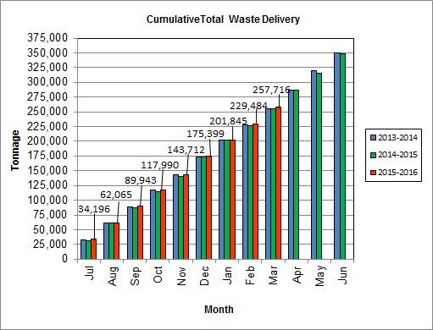

As depicted in Table 3 and Chart 8, for the period ending in March 2016; cumulative total waste delivery was 0.9% more compared to the same period in FY15.

Chart 9: Gross Electrical Generation

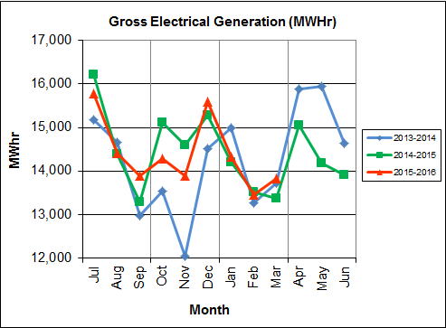

During Q3FY16, the Facility generated 41,606 MWhrs (gross) of electricity compared to Q3FY15 generation of 41,107 MWhrs (gross), a 1.2% increase. The increase in gross electrical generation in Q3FY16 as compared to Q3FY15 is attributable to the increase in steam production, paired with less downtime (6.3 fewer hours) experienced by the boilers, and an additional day of operations as a result of the Leap Year. Note that the sharp spikes depicted in Chart Nos. 10 through 14 for the months of May and June 2015 are a result of significant downtime (424.7 hours) experienced by Turbine Generator No. 1 to repair an exciter failure in the generator. A similar spike is depicted in the same charts for November 2013 as a result of Turbine Generator No. 2 experiencing significant downtime (494.8 hours) for a Major Overhaul.

Chart 10: Gross Conversion Rate

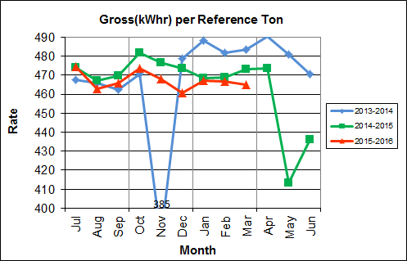

As shown in Chart 10, the average gross electrical generation per reference ton of refuse processed during Q3FY16 was 466 kWhr, which is 0.8% lower than the corresponding quarter in FY15. Since this calculated value uses reference or normalized tonnages of waste, it should cancel the effect of MSW heating value (Btu content) variability.

Chart 11: Net Conversion Rate

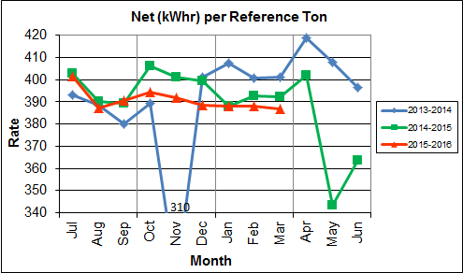

Chart 11 depicts the normalized net power (gross minus in-house usage) generation history. In Q3FY16, the average net electrical generation per reference ton was 388 kWhr, which is 0.9% lower than the corresponding quarter in FY15.

Chart 12: Net Conversion Rate

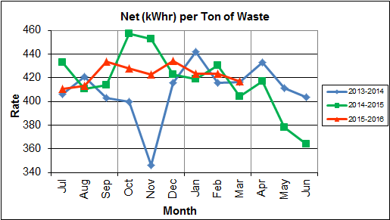

Chart 12 depicts the net power generation per processed ton. The net electrical generation per processed ton in Q3FY16 was 421 kWhr, which is 0.9% higher than the corresponding quarter in FY15.

Chart 13: Gross Turbine Generator Conversion Rate

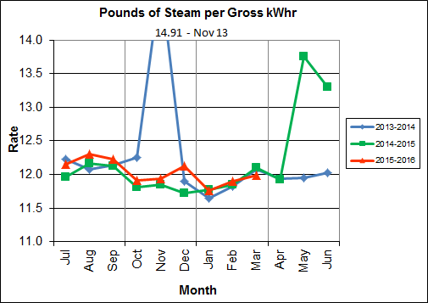

Charts 13 and 14 illustrate the quantities of steam required to generate one kWhr of electricity, gross and net respectively. This measure is a turbine generator performance indicator, where lower steam rates indicate superior performance. For simplification, this calculated rate is based on the average for the two turbine generators. In Q3FY16 the average lbs of steam consumed per gross kWhr generated was 11.9, which is slightly lower (0.2%) than the corresponding quarter Q3FY15, and indicative of slightly improved performance. A factor that negatively impacts this metric is Turbine Generator No. 2 continues to operate with its Stage 9 blades removed from the rotor. CAAI reported that during the Turbine Generator No. 2 overhaul in November 2013, some cracking was observed on the Stage 9 blades of the rotor, and the blading in that row was removed as a precautionary measure. CAAI originally indicated that a new set of blades would be manufactured and installed during a Turbine Generator No. 2 Outage in 2016, but advised in May 2015, that the implementation of the replacement blades installation would be delayed. The average lbs of steam consumed per net kWhr was 14.3, which is slightly lower (0.2%) than the corresponding quarter in FY15. The average steam temperature during the quarter was 675.3° F, which is 0.2% lower than the average steam temperature of the corresponding quarter last year and 24.7° F lower than design temperature of 700o F.

Chart 14: Net Turbine Generator Conversion Rate

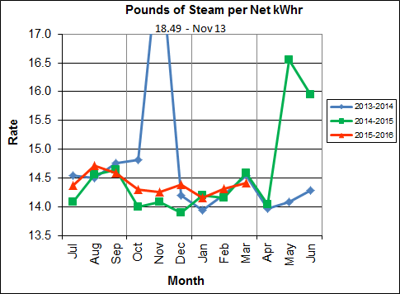

## Utility and Reagent Consumptions

Table 4: Facility Utility and Reagent Consumptions

|  |  |  |  |  |  |  |  |
| --- | --- | --- | --- | --- | --- | --- | --- |
| **Utility** | **Units** | **Q3FY16 Total** | **Q3FY15**  **Total** | **Q3FY16”Per Processed Ton” Consumption** | **Q3FY15”Per Processed Ton” Consumption** | **FY16**  **YTD Total** | **FY15**  **Total** |
| **Purchased Power** | MWhr | 5,554 | 5,475 | 0.07 | 0.07 | 16,591 | 22,001 |
| **Fuel Oil** | Gal. | 9,960 | 12,990 | 0.12 | 0.16 | 29,520 | 35,920 |
| **Boiler Make-up** | Gal. | 2,205,000 | 1,908,000 | 26.86 | 23.30 | 6,019,000 | 8,501,000 |
| **Cooling Tower Make-up** | Gal. | 27,464,971 | 24,834,867 | 334.59 | 303.32 | 104,838,010 | 143,594,395 |
| **Pebble Lime** | Lbs. | 1,304,000 | 1,302,000 | 15.89 | 15.90 | 4,034,000 | 5,254,000 |
| **Ammonia** | Lbs. | 147,000 | 142,000 | 1.79 | 1.73 | 480,000 | 632,000 |
| **Carbon** | Lbs. | 102,000 | 100,000 | 1.24 | 1.22 | 306,000 | 408,000 |
| **Dolomitic Lime** | Lbs. | 145,800 | 200,400 | 1.78 | 2.45 | 563,800 | 1,007,200 |

Fuel oil usage during the quarter represents approximately 0.19% of the total heat input to the boilers, which compares favorably with industry averages, and slightly lower than the percentage of heat input in Q3FY15 which was 0.17%. Fuel oil is used to stabilize combustion of wet fuel, as well as during start-up and shut-down of the boilers for maintenance. Boiler makeup water usage during the quarter represents 2.9% of steam flow, which is lower than the boiler makeup in Q3FY15 which was 3.5%, and is acceptable. Pebble lime usage, at 1,304,000 lbs. is slightly higher (0.2%) than the corresponding quarter last year, and the quarterly consumption rate of 15.9 lbs/ton is comparable to historical levels (16-18 lbs/ton).

In comparing Q3FY16 to Q3FY15 on a per processed ton consumption basis:

* the purchased power consumption rate was 1.2% higher
* the total fuel oil consumption rate was 23.5% lower
* the boiler make-up water consumption rate was 15.3% higher
* the cooling tower make-up water consumption rate was 10.3% higher
* the total pebble lime consumption rate was 0.1% lower
* the ammonia consumption rate was 3.3% higher
* the carbon consumption rate was 1.7% lower
* the total dolomitic lime consumption rate was 27.4% lower

Note that following the February 2016 FMG Meeting, CAAI provided 3 year historical dolomitic lime usage based on deliveries, starting silo inventory, and ending silo inventory. CAAI reports that the decrease in dolomitic lime usage during the quarter was attributable to lowering the set point on the controller, and inaccuracies of utilizing the level indicator for usage.

## Safety & Environmental Training

On January 16, 2016, an OSHA recordable accident occurred at the facility when an operator broke a finger while cleaning out the ash discharger. CAAI reports that it has modified the safety measures when dischargers are cleaned to wear a pair of shielded gloves to prevent future incidents. Before the OSHA recordable accident occurred, the Facility operated 1,869 days without an incident. Through the end of March 2016, the Facility has operated 75 days without an OSHA recordable incident. During the quarter, Safety and Environmental training was conducted with themes as follows:

**January 2016**

* Safety:
  + Hazard Recognition
  + Accident Prevention
  + Near Miss Reporting
* Environmental:
  + Environmental Mission Statement
  + New/Upcoming Company and Regulatory Changes
  + Environmental Compliance and Covanta Environmental Technical Standards

**February 2016**

* Safety:
  + Heavy Metals
  + Respiratory Protection
  + Safety and Health Policy
  + Employee Rights and Responsibilities
  + Pre-Job Planning
  + Line-of-Fire Injuries and Prevention
* Environmental:
  + Environmental Permits:
    - Air
    - Water
    - Solid Waste

**March 2016**

* Safety:
  + Personal Protective Equipment
  + Field Remote Lock Box
  + Outage Housekeeping
* Environmental:
  + Carbon Monoxide
  + Opacity
  + Purple Plumes

# Facility Maintenance

Throughout the quarter, significant routine and preventative maintenance was performed. HDR considers that the Facility is implementing an effective maintenance regimen, and is performing routine and preventative maintenance, along with selected equipment replacements in a timely manner. CAAI monthly maintenance reports provide a detailed account of maintenance performed.

Beginning January 24th, Boiler No. 2 experienced 135.5 hours of downtime for scheduled maintenance. Some significant maintenance activities that occurred during the outage were:

* Removal and replacement of the G221 Scrubber screw conveyor screws, shafts, hanger bearings, and pillow block bearings
* Replacement of all the feed table bars
* Replacement of both feed ram sleds with all new bars, slide shoes, support rollers, and guide rollers along with the side wall wear plates, and triangular brake plates
* Replacement of elements on G9B Sootblower Nos. 4, 7, and 14
* Replacement of one (1) broken grate bar and also 2 driving beam support rollers
* Replacement of the lower four (4) feet on each baghouse hopper with stainless steel.

Beginning February 27th, Boiler No. 1 experienced 138.0 hours of downtime for scheduled maintenance. Some significant maintenance activities that occurred during the outage were:

* Removal and replacement of the G121 scrubber screw conveyor screws, shafts, hanger bearings, and pillow block bearings
* Removal and replacement of the chemical injection valve on the 6th floor prior to the steam drum
* Repair of a crack in the wall by the steam drum on the 6th floor
* Repair of several driving beam wear strips and also change-out of two (2) support rollers
* Replacement of the Induced Draft Fan Coupling Hubs and sleeves
* Replacement of the drain line valves on Nos. 1 and 2 Condensate Pumps
* Repair of a hole in “D” Baghouse Cell Tube Sheet
* Replacement of two (2) soot blower elements, G9B Nos. 3 and 4
* Replacement of 32 tube shields in the superheater section
* Repair of holes in the “A, B, C, D, and E” Baghouse Cells
* Replacement of six (6) missing tabs and bolts in the steam drum
* Installation of a new door for safer clearing of transition chute plugs at the rear of the boiler on the 1.5 level
* Replating of almost half of the ash discharger transverse wall
* Change-out of the oil on all the fly ash screw conveyors, and dolomitic lime conveyors
* Installation of an angle drain valve on the ash discharger
* Repair of several holes in the inlet duct to the baghouse
* Repair of several holes in the inlet duct to the Induced Draft Fan
* Repair of a stack test port by the opacity monitor

Beginning February 28th, Turbine Generator No. 1 experienced 135.6 hours of downtime for scheduled maintenance. Some significant maintenance activities that occurred during the outage were:

* Repair of a steam leak on a hogger suction valve
* Replacement of gaskets on inner and post-condenser flanges
* Disconnection of electrical hook-ups on end bell housings for removal
* Cleaning of the generator coolers
* Taping of Generator links
* Installation of additional axial probe on the thrust bearing and reprogramming of the Bentley Nevada
* Borescope of the turbine and inspection of the T&T Valves
* Removal and reworking of the Non-Return Valves
* Testing of Generator
* Rewiring of generator links
* Rewiring of RTD’s and installation of new flex hose on the generator inside bell housing
* Cleaning of the lube oil coolers
* Rewiring of RTD’s and installation of new flex hose on the exciter end bell housing

Beginning March 5th, Boiler No. 3 experienced 138.4 hours of downtime for scheduled maintenance. Some significant maintenance activities that occurred during the outage were:

* Replacement of the ash discharger ram arms, ram face, scraper, wear plates, ram bushings, and pins
* Replacement of a section of the ash discharger wall on the north side between the lower and upper doors
* Replacement of two (2) missing driving beam wear strips
* Replating of eight (8) feet of the feed chute hopper
* Replacement of three (3) Sootblower elements, G9B Nos. 3, 7, and 14
* Installation of new inconel overlaid element in G9B No. 7 position
* Replacement of a total of 21 tube shields
* Replacement of the auxiliary burner slide gate
* Change-out of the oil on all the gearboxes on the screw conveyors for the fly ash system, and also the dolomitic lime conveyors
* Repair of a hole in Baghouse Hopper “A” Cell
* Installation of a new door for safer clearing of transition chute plugs at the rear of the boiler on the 1.5 level
* Replacement of one (1) ignition roof curve block
* Repair of a hole in the wall by IK No. 7
* Repair of the center stack test port by the opacity monitor
* Change-out of the Induced Draft Fan coupling hubs and sleeves
* Repair of several holes in the baghouse inlet duct

In addition to the scheduled maintenance activities conducted on all three boilers and Turbine Generator No. 1, CAAI reports that 1,121 preventative maintenance actions were completed during the quarter.

## Availability

Facility availabilities for Q3FY16 are shown in Table 5. According to CAAI reports, the average unit availabilities for Boiler Nos. 1, 2, and 3 for Q3FY16 were 92.8%, 93.9%, and 93.8%, respectively. The three-boiler average availability during the quarter was 93.5%, which was negatively impacted by downtime, primarily for scheduled maintenance.

During Q3FY16, the average availability for Turbine Generator Nos. 1 and 2 was 93.8% and 99.5%, respectively. The two-turbine generator average availability during the quarter was 96.6%, which was negatively impacted by the Turbine Generator No. 1 scheduled maintenance in February and March 2016.

Table 5: Quarterly Facility Unit Availabilities

|  |  |  |  |  |
| --- | --- | --- | --- | --- |
| **Availability** | **Q1FY16 Average** | **Q2FY16 Average** | **Q3FY16 Average** | **FY16 YTD Average** |
| Boiler No. 1 | 94.1% | 100.0% | 92.8% | 95.6% |
| Boiler No. 2 | 97.9% | 94.6% | 93.9% | 95.5% |
| Boiler No. 3 | 98.5% | 94.4% | 93.8% | 95.6% |
| ***Avg.*** | ***96.8%*** | ***96.3%*** | ***93.5%*** | ***95.6%*** |
| Turbine No. 1 | 99.0% | 100.0% | 93.8% | 97.6% |
| Turbine No. 2 | 99.1% | 100.0% | 99.5% | 99.5% |
| ***Avg.*** | ***99.0%*** | ***100.0%*** | ***96.6%*** | ***98.6%*** |

## Downtime Summary

Table 6: Boiler Downtime – Q3FY16

|  |  |  |  |  |  |  |
| --- | --- | --- | --- | --- | --- | --- |
| **Boiler Number** | **Outage Begin Date** | **Outage End Date** | **Hours Unavailable** | | **Downtime**  **Classification** | **Reason Unavailable** |
| 3 | 1/14/16 | 1/16/16 | 47.8 | | Standby | Preventative measure taken to avoid exceeding 350,000 ton rolling 12-month process limit |
| 1 | 1/22/16 | 1/23/16 | 19.0 | | Unscheduled | Grate Bar Failure |
| 2 | 1/22/16 | 1/23/16 | 48.0 | | Standby | Preventative measure taken to avoid exceeding 350,000 ton rolling 12-month process limit |
| 2 | 1/24/16 | 1/29/16 | 135.5 | | Scheduled | Boiler No. 2 Scheduled Maintenance |
| 2 | 2/20/16 | 2/20/16 | 0.6 | | Unscheduled | Troubleshooting a permissive for the Under Fire Air Fan |
| 1 | 2/26/16 | 2/27/16 | 24.0 | | Standby | Preventative measure taken to avoid exceeding 350,000 ton rolling 12-month process limit |
| 1 | 2/27/16 | 3/4/16 | 138.0 | | Scheduled | Boiler No. 1 Scheduled Maintenance |
| 1 | 3/4/16 | 3/5/16 | 10.7 | | Standby | Preventative measure taken to avoid exceeding 350,000 ton rolling 12-month process limit |
| 3 | 3/5/16 | 3/11/16 | 138.4 | | Scheduled | Boiler No. 3 Scheduled Maintenance |
| **Total Unscheduled Downtime** | | | | **19.6 Hours** | | |
| **Total Scheduled Downtime** | | | | **411.9 Hours** | | |
| **Total Standby Downtime** | | | | **130.5 Hours** | | |
| **Total Downtime** | | | | **562.0 Hours** | | |

Table 7: Turbine Generator Downtime – Q3FY16

|  |  |  |  |  |  |  |
| --- | --- | --- | --- | --- | --- | --- |
| **Turbine Generator Number** | **Outage Begin Date** | **Outage End Date** | **Hours Unavailable** | | **Downtime**  **Classification** | **Reason Unavailable** |
| 1 | 1/26/16 | 1/27/16 | 43.0 | | Standby | Preventative measure taken to avoid exceeding 350,000 ton rolling 12-month process limit |
| 2 | 1/22/16 | 1/26/16 | 98.5 | | Standby | Preventative measure taken to avoid exceeding 350,000 ton rolling 12-month process limit |
| 1 | 2/28/16 | 3/4/16 | 135.6 | | Scheduled | Turbine Generator No. 1 Scheduled Maintenance |
| 2 | 2/28/16 | 2/29/16 | 10.5 | | Unscheduled | Condenser Tube Leak |
| **Total Unscheduled Downtime** | | | | **10.5 Hours** | | |
| **Total Scheduled Downtime** | | | | **135.6 Hours** | | |
| **Total Standby Downtime** | | | | **141.5 Hours** | | |
| **Total Downtime** | | | | **287.6 Hours** | | |

## Facility Housekeeping

CAAI is performing Facility housekeeping and maintaining plant cleanliness in accordance with acceptable industry practices. A site inspection was conducted in February 2016. At the time of the inspection, new deficiencies were recorded and prior deficiencies were given a status update. Photos of interest from the inspection are depicted in Appendix B. The Facility housekeeping ratings from the February 2016 inspection are presented in Table 8.

Table 8: Facility Housekeeping Ratings – February 2016

| **Facility Area** | **Acceptable** | **Needs Improvement** | **Unacceptable** |
| --- | --- | --- | --- |
| **Tipping Floor** | √ |  |  |
| **Citizen’s Drop-off Area** | √ |  |  |
| **Tipping Floor Truck Exit** | √ |  |  |
| **Front Parking Lot** | √ |  |  |
| **Rear Parking Lot** | √ |  |  |
| **Boiler House Pump Room** | √ |  |  |
| **Lime Slurry Pump Room** | √ |  |  |
| **Switchgear Area** | √ |  |  |
| **Ash Load-out Area** | √ |  |  |
| **Vibrating Conveyor Area** | √ |  |  |
| **Ash Discharger Area** | √ |  |  |
| **Cooling Tower Area** | √ |  |  |
| **Truck Scale Area** | √ |  |  |
| **SDA/FF Conveyor Area** | √ |  |  |
| **SDA Penthouses** | √ |  |  |
| **Lime Preparation Area** | √ |  |  |
| **Boiler Drum Levels** | √ |  |  |
| **Turbine Room** | √ |  |  |
| **Electrical Room** | √ |  |  |

# Environmental

The retrofit air pollution control equipment maintained emission concentrations well within the established regulations. Average Continuous Emission Monitoring System (CEMS) data collected for each monthly period during Q3FY16 are summarized in Appendix A. No permit deviations were experienced by the Facility during Q3FY16.

On August 8, 2014, CAAI sent a letter to the Virginia Department of Environmental Quality (VADEQ) requesting relief from the steam permit limit requirements in the Facility’s Title V and PSD permits. These requested changes relate to the permit values established for the calculated steam-to-waste ratio, which has resulted in a reduction of MSW throughput. In recent discussions, CAAI indicated that it is re-evaluating options to the proposed permit changes, and will provide further updates on this issue.

## Nitrogen Oxide Emissions

During Q3FY16, the monthly emission concentrations of nitrogen oxides (NOx) averaged 163.3 ppmdv, 162.7 ppmdv and 162.3 ppmdv for Boiler Nos. 1, 2, and 3, respectively. CAAI continues to operate the units at the lower (160 ppmdv) set-points, except immediately following a scheduled outage and associated boiler cleaning.

## Sulfur Dioxide Emissions

During Q3FY16 the monthly emission concentration of stack sulfur dioxide (SO2) averaged 1.3 ppmdv, 1.0 ppmdv, and 0.7 ppmdv for Boiler Nos. 1, 2, and 3, respectively. All of these stack SO2 concentrations are significantly below the 40 CFR Subpart Cb requirement of 29 ppmdv @ 7% O2.

## Carbon Monoxide Emissions

During Q3FY16, the average CO emission concentrations on Boiler Nos. 1, 2, and 3 were 39.3 ppmdv, 37.3 ppmdv, and 39.0 ppmdv, respectively, and all are well within permit limits (100 ppmdv, hourly average).

## Opacity

During Q3FY16, the average opacity for Boiler Nos. 1, 2, and 3 was 1.5%, 0.1%, and 1.0% respectively. All of these averages are significantly below the 10% (6-minute) average permit limit.

## Daily Emissions Data

Appendix A, Tables 10, 11, and 12 tabulate the monthly average, maximum, and minimum emissions data for each unit during Q3FY16. Excursions, if any, would appear in bold print. It should be noted that these tabulations of monthly averages, reported here for informational purposes, are based on tabulations of daily averages. These averages do not correlate with official reports to the regulatory agencies because of differences in averaging times and other technical differences required by agency report formats.

## 2016 Annual Stack Testing

Annual stack testing was conducted March 21st through March 23rd, 2016 by Testar Inc. Historical stack test data including 2016 results are summarized in Chart 15 and Table 9. The 2016 test results demonstrate compliance well within the permit limits for all parameters. In addition to the tests required by the Facility permit, additional tests for small particulate matter (PM < 2.5) were conducted. While there are no current regulatory limits established for PM < 2.5, average results for 2016 were 0.005 Gr/DSCF (grains per dry standard cubic foot) corrected to 7% O­2, compared to the 2015 Annual Stack Testing PM <2.5 Results which averaged 0.003 Gr/DSCF corrected to 7% O­2.

Chart 15: Stack Test Results through 2016

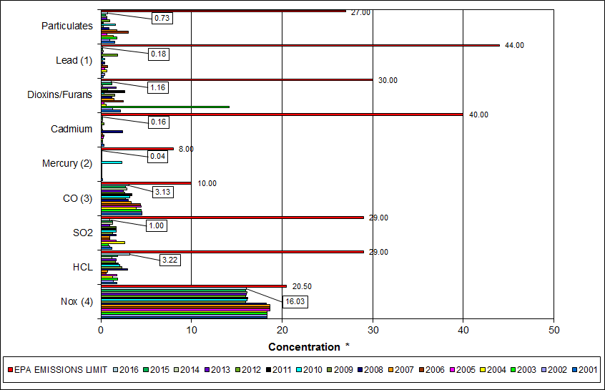

|  |
| --- |
| Note (1): Lead emissions have been decreased by a factor of 10 for trending purposes |
| Note (2): Mercury emissions have been decreased by a factor of 100 for trending purposes |
| Note (3): CO emissions have been decreased by a factor of 10 for trending purposes |
| Note (4): NOx emissions have been decreased by a factor of 10 for trending purposes |

Table 9: Stack Test Results through 2016

|  |  |  |  |  |  |  |  |  |  |  |  |
| --- | --- | --- | --- | --- | --- | --- | --- | --- | --- | --- | --- |
|  |  | **NOx(4)** | **HCL** | **SO2** | **CO(3)** | **Mercury(2)** | **Cadmium** | **Dioxins/Furans** | **Lead(1)** | **Particulates** | **P.M. 2.5** |
|  |  | **(ppmdv)** | **(ppmdv)** | **(ppmdv)** | **(ppmdv)** | **(ug/dscm)** | **(ug/dscm)** | **(ng/dscm)** | **(ug/dscm)** | **(mg/dscm)** | **(gr/dscf)** |
| **2006** | Boiler 1 | 187 | 0.85 | 1 | 43 | 0.38 | 0.4 |  | 7.79 | 4.84 | -- |
| Boiler 2 | 185 | 0.483 | 1 | 47 | 0.4 | 0.19 |  | 2.51 | 2.15 | -- |
| Boiler 3 | 189 | 0.529 | 1 | 42 | 0.4 | 0.57 | 2.48 | 12.4 | 2 | -- |
| **AVERAGE** | **187.0** | **0.62** | **1.00** | **44.00** | **0.39** | **0.39** | **2.48** | **7.57** | **3.00** | **--** |
|  |  |  |  |  |  |  |  |  |  |  |  |
| **2007** | Boiler 1 | 187 | 0.82 | 1 | 31 | 0.38 | 0.25 |  | 2.31 | 2.03 | -- |
| Boiler 2 | 185 | 0.68 | 1 | 36 | 0.39 | 0.19 | 1.42 | 2.12 | 2.04 | -- |
| Boiler 3 | 189 | 0.84 | 1 | 34 | 0.59 | 0.16 |  | 1.55 | 1.33 | -- |
| **AVERAGE** | **187.0** | **0.78** | **1.00** | **33.67** | **0.46** | **0.20** | **1.42** | **1.99** | **1.80** | **--** |
|  |  |  |  |  |  |  |  |  |  |  |  |
| **2008** | Boiler 1 | 181 | 2.96 | 2 | 37 | 0.45 | 6.60 | 1.25 | 9.4 | 1.46 | -- |
| Boiler 2 | 182 | 3.52 | 2 | 30 | 0.42 | 0.50 |  | 2.6 | 0.82 | -- |
| Boiler 3 | 186 | 2.43 | 1 | 24 | 1.03 | 0.16 |  | 0.23 | 0.48 | -- |
| **AVERAGE** | **183.0** | **3.0** | **1.67** | **30.3** | **0.63** | **2.4** | **1.25** | **4.1** | **0.9** | **--** |
|  |  |  |  |  |  |  |  |  |  |  |  |
| **2009** | Boiler 1 | 159 | 1.40 | 2 | 28 | 0.184 | 0.191 |  | 2.260 | 0.483 | -- |
| Boiler 2 | 158 | 2.12 | 1 | 25 | 0.271 | 0.143 |  | 0.894 | 0.068 | -- |
| Boiler 3 | 163 | 3.53 | 1 | 29 | 0.198 | 0.256 | 1.54 | 3.030 | 0.155 | -- |
| **AVERAGE** | **160** | **2.35** | **1.33** | **27.33** | **0.22** | **0.20** | **1.54** | **2.061** | **0.235** | **--** |
|  |  |  |  |  |  |  |  |  |  |  |  |
| **2010** | Boiler 1 | 159 | 2.69 | 1 | 29 | 5.76 | 0.120 |  | 1.33 | 3.690 | 0.00410 |
| Boiler 2 | 158 | 0.67 | 1 | 28 | 29.50 | 0.032 | 0.35 | 3.00 | 0.914 | 0.00630 |
| Boiler 3 | 168 | 2.85 | 3 | 38 | 34.70 | 0.241 |  | 8.71 | 0.336 | 0.00990 |
| **AVERAGE** | **161.7** | **2.07** | **1.67** | **31.67** | **23.32** | **0.13** | **0.35** | **4.347** | **1.647** | **0.007** |
|  |  |  |  |  |  |  |  |  |  |  |  |
| **2011** | Boiler 1 | 167 | 2.15 | 2 | 28 | 0.36 | 0.140 | 2.67 | 1.72 | 0.130 | 0.00570 |
| Boiler 2 | 159 | 1.14 | 1 | 38 | 0.44 | 0.140 |  | 1.46 | 0.350 | 0.00690 |
| Boiler 3 | 161 | 2.40 | 2 | 37 | 0.36 | 0.110 |  | 1.47 | 0.350 | 0.00170 |
| **AVERAGE** | **162.3** | **1.90** | **1.67** | **34.33** | **0.39** | **0.13** | **2.67** | **1.550** | **0.277** | **0.005** |
|  |  |  |  |  |  |  |  |  |  |  |  |
| **2012** | Boiler 1 | 163 | 1.14 | 2 | 23 | 0.30 | 0.310 |  | 1.34 | 0.640 | 0.00932 |
| Boiler 2 | 156 | 2.02 | 2 | 29 | 0.34 | 0.250 | **0.75** | 6.52 | 1.280 | 0.00782 |
| Boiler 3 | 161 | 1.66 | 1 | 27 | 0.37 | 0.590 |  | 47.80 | 1.020 | 0.00679 |
| **AVERAGE** | **160.0** | **1.61** | **1.67** | **26.33** | **0.34** | **0.38** | **0.75** | **18.553** | **0.980** | **0.008** |
|  |  |  |  |  |  |  |  |  |  |  |  |
| **2013** | Boiler 1 | 164 | 1.48 | 1 | 28 | 0.36 | 0.134 |  | 1.45 | 0.637 | 0.00637 |
| Boiler 2 | 158 | 1.98 | 1 | 25 | 0.37 | 0.112 | 1.66 | 1.05 | 0.737 | 0.00475 |
| Boiler 3 | 159 | 1.52 | 1 | 22 | 0.42 | 0.137 |  | 3.03 | 0.733 | 0.00471 |
| **AVERAGE** | **160.3** | **1.66** | **1.00** | **25.00** | **0.38** | **0.13** | **1.66** | **1.843** | **0.702** | **0.005** |
|  |  |  |  |  |  |  |  |  |  |  |  |
| **2014** | Boiler 1 | 167 | 1.13 | 2 | 35 | 0.33 | 0.270 | 0.16 | 3.82 | 0.282 | 0.00337 |
| Boiler 2 | 157 | 1.02 | 1 | 35 | 0.35 | 0.183 |  | 2.52 | 1.240 | 0.00415 |
| Boiler 3 | 161 | 1.50 | 1 | 17 | 0.49 | 0.228 |  | 2.85 | 0.520 | 0.00425 |
| **AVERAGE** | **161.7** | **1.22** | **1.33** | **29.00** | **0.39** | **0.23** | **0.16** | **3.063** | **0.681** | **0.004** |
|  |  |  |  |  |  |  |  |  |  |  |  |
| **2015** | Boiler 1 | 164 | 1.80 | 2 | 25 | 0.32 | 0.102 |  | 1.00 | 0.513 | 0.00540 |
| Boiler 2 | 157 | 1.99 | 1 | 29 | 0.38 | 0.109 |  | 1.30 | 0.532 | 0.00410 |
| Boiler 3 | 159 | 1.71 | 1 | 27 | 0.39 | 0.409 | 1.21 | 3.04 | 0.499 | 0.00074 |
| **AVERAGE** | **160.0** | **1.83** | **1.33** | **27.00** | **0.36** | **0.21** | **1.21** | **1.778** | **0.515** | **0.003** |
|  |  |  |  |  |  |  |  |  |  |  |  |
| **2016** | Boiler 1 | 166 | 4.33 | 1.0 | 29 | 0.46 | 0.231 |  | 2.81 | 1.170 | 0.00680 |
| Boiler 2 | 156 | 3.46 | 1.0 | 37 | 0.43 | 0.154 | 1.16 | 1.13 | 0.657 | 0.00241 |
| Boiler 3 | 159 | 1.86 | 1.0 | 28 | 0.38 | 0.107 |  | 1.59 | 0.371 | 0.00456 |
| **AVERAGE** | **160.3** | **3.22** | **1.00** | **31.33** | **0.42** | **0.16** | **1.16** | **1.843** | **0.733** | **0.005** |
|  |  |  |  |  |  |  |  |  |  |  |  |
|  | **EPA EMISSIONS LIMIT** | 205 | 29 | 29 | 100 | 80 | 40 | 30 | 440 | 27 | -- |
| **Percent of Limit for 2016** | **78.2%** | **11.1%** | **3.4%** | **31.3%** | **0.5%** | **0.4%** | **3.9%** | **0.4%** | **2.7%** | -- |

## 

## Ash System Compliance

The dolomitic lime feed rate is adjusted periodically in order to maintain a desired ash pH level in the range of 8.0 to 11.0. Since initial startup, the feed rate has varied from between 1 to 9 lbs per ton each month. Ash Toxicity (TCLP) tests were not performed during Q3FY16.

CAAI also samples ash monthly in-house, and documents pH reading to adjust dolomitic lime feed rate. The results for the ash pH tests are found below in Chart 15 where each quarter is represented by the average of the respective monthly readings. During Q3FY15, the average ash pH for in-house tests was 9.5.

Chart 16: Quarterly Ash Test Results

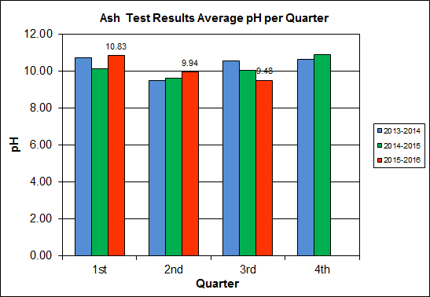

APPENDIX A  
FACILITY CEMS DATA

Table 10: Unit #1 Monthly Summary for Reportable Emissions Data

|  |  |  |  |  |  |  |  |  |  |  |
| --- | --- | --- | --- | --- | --- | --- | --- | --- | --- | --- |
| **Group#-Channel#** | | **G8-C35** | **G8-C28** | **G8-C8** | **G8-C4** | **G8-C12** | **G8-C34** | **G8-C37** | **G8-C40** | **G8-C39** |
| **Long Descrip.** | | **U-1 Steam** | **U-1 Econ** | **U-1 Stack** | **U-1 Stack** | **U-1 Stack** | **U-1 Opaci** | **U-1 FF In** | **U-1 Carbo** | **U-1 Lime** |
| **Short Descrip.** | | **SteamFl** | **SO2ec** | **SO2sc** | **COsc** | **NOxsc** | **Opacity** | **FF InTemp** | **CarbInj** | **LimeFlow** |
| **Units** | | **K#/Hr** | **ppmc** | **ppm** | **ppmc** | **ppmc** | **%** | **deg F** | **#/hr** | **gpm** |
| **Range** | | **0-100** | **0-2000** | **0-500** | **0-4000** | **0-1000** | **0-100** | **100-500** | **0-50** | **0-20** |
| Jan-16 | AVG | 81.4 | 32.0 | 1.0 | 42.0 | 161.0 | 1.8 | 303.0 | 16.4 | 3.0 |
| Max | 86.1 | 70.0 | 5.0 | 57.0 | 180.0 | 2.4 | 304.0 | 16.8 | 3.3 |
| Min | 78.1 | 12.0 | 0.0 | 29.0 | 155.0 | 1.2 | 302.0 | 16.2 | 2.8 |
| Feb-16 | AVG | 78.1 | 28.0 | 1.0 | 38.0 | 159.0 | 1.5 | 305.0 | 16.4 | 3.1 |
| Max | 84.5 | 53.0 | 3.0 | 46.0 | 163.0 | 2.3 | 306.0 | 16.5 | 3.3 |
| Min | 72.4 | 11.0 | 0.0 | 25.0 | 155.0 | 1.0 | 304.0 | 16.3 | 2.9 |
| Mar-16 | AVG | 82.1 | 67.0 | 2.0 | 38.0 | 170.0 | 1.3 | 306.0 | 16.2 | 3.2 |
| Max | 88.3 | 123.0 | 12.0 | 53.0 | 186.0 | 1.7 | 307.0 | 16.8 | 3.8 |
| Min | 72.4 | 48.0 | 0.0 | 27.0 | 158.0 | 0.6 | 301.0 | 14.7 | 2.8 |
| **Quarter Average** | | 80.5 | 42.3 | 1.3 | 39.3 | 163.3 | 1.5 | 304.7 | 16.3 | 3.1 |
| **Quarter Max Value** | | 88.3 | 123.0 | 12.0 | 57.0 | 186.0 | 2.4 | 307.0 | 16.8 | 3.8 |
| **Quarter Min Value** | | 72.4 | 11.0 | 0.0 | 25.0 | 155.0 | 0.6 | 301.0 | 14.7 | 2.8 |
| **Limits:** | | 98 | NA | 29 | 100 | 205 | 10 | 333 | 16(a) |  |

(a) Carbon flow limit is a minimum value

* Note: The data reported herein represent 24 hour average data for all parameters. Emissions excursions that are measured on shorter time intervals (i.e., 4-hour block averages for CO) do not correlate with the 24 hour average data reported above.

Table 11: Unit #2 Monthly Summary for Reportable Emissions Data

|  |  |  |  |  |  |  |  |  |  |  |
| --- | --- | --- | --- | --- | --- | --- | --- | --- | --- | --- |
| **Group#-Channel#** | | **G8-C35** | **G8-C28** | **G8-C8** | **G8-C4** | **G8-C12** | **G8-C34** | **G8-C37** | **G8-C40** | **G8-C39** |
| **Long Descrip.** | | **U-2 Steam** | **U-2 Econ** | **U-2 Stack** | **U-2 Stack** | **U-2 Stack** | **U-2 Opaci** | **U-2 FF In** | **U-2 Carbo** | **U-2 Lime** |
| **Short Descrip.** | | **SteamFl** | **SO2ec** | **SO2sc** | **COsc** | **NOxsc** | **Opacity** | **FF InTemp** | **CarbInj** | **LimeFlow** |
| **Units** | | **K#/Hr** | **ppmc** | **ppm** | **ppmc** | **ppmc** | **%** | **deg F** | **#/hr** | **gpm** |
| **Range** | | **0-100** | **0-2000** | **0-500** | **0-4000** | **0-1000** | **0-100** | **100-500** | **0-50** | **0-20** |
| Jan-16 | AVG | 82.9 | 40.0 | 1.0 | 43.0 | 161.0 | 0.2 | 300.0 | 16.5 | 3.1 |
| Max | 86.1 | 101.0 | 7.0 | 53.0 | 176.0 | 0.7 | 301.0 | 18.4 | 3.4 |
| Min | 80.3 | 21.0 | 0.0 | 34.0 | 155.0 | 0.0 | 298.0 | 16.2 | 2.9 |
| Feb-16 | AVG | 76.1 | 74.0 | 1.0 | 31.0 | 168.0 | 0.1 | 300.0 | 16.4 | 3.2 |
| Max | 84.8 | 98.0 | 6.0 | 39.0 | 185.0 | 0.6 | 302.0 | 16.7 | 3.6 |
| Min | 70.6 | 46.0 | 0.0 | 24.0 | 156.0 | 0.0 | 299.0 | 16.2 | 2.9 |
| Mar-16 | AVG | 80.8 | 54.0 | 1.0 | 38.0 | 159.0 | 0.0 | 300.0 | 16.2 | 3.4 |
| Max | 86.8 | 113.0 | 10.0 | 50.0 | 172.0 | 0.1 | 301.0 | 16.7 | 5.1 |
| Min | 72.0 | 28.0 | 0.0 | 24.0 | 156.0 | 0.0 | 294.0 | 14.8 | 2.9 |
| **Quarter Average** | | 79.9 | 56.0 | 1.0 | 37.3 | 162.7 | 0.1 | 300.0 | 16.4 | 3.2 |
| **Quarter Max Value** | | 86.8 | 113.0 | 10.0 | 53.0 | 185.0 | 0.7 | 302.0 | 18.4 | 5.1 |
| **Quarter Min Value** | | 70.6 | 21.0 | 0.0 | 24.0 | 155.0 | 0.0 | 294.0 | 14.8 | 2.9 |
| **Limits:** | | 96 | NA | 29 | 100 | 205 | 10 | 330 | 16(a) |  |

(a) Carbon flow limit is a minimum value

* Note: The data reported herein represent 24 hour average data for all parameters. Emissions excursions that are measured on shorter time intervals (i.e., 4-hour block averages for CO) do not correlate with the 24 hour average data reported above.

Table 12: Unit #3 Monthly Summary for Reportable Emissions Data

|  |  |  |  |  |  |  |  |  |  |  |
| --- | --- | --- | --- | --- | --- | --- | --- | --- | --- | --- |
| **Group#-Channel#** | | **G8-C35** | **G8-C28** | **G8-C8** | **G8-C4** | **G8-C12** | **G8-C34** | **G8-C37** | **G8-C40** | **G8-C39** |
| **Long Descrip.** | | **U-3 Steam** | **U-3 Econ** | **U-3 Stack** | **U-3 Stack** | **U-3 Stack** | **U-3 Opaci** | **U-3 FF In** | **U-3 Carbo** | **U-3 Lime** |
| **Short Descrip.** | | **SteamFl** | **SO2ec** | **SO2sc** | **COsc** | **NOxsc** | **Opacity** | **FF InTemp** | **CarbInj** | **LimeFlow** |
| **Units** | | **K#/Hr** | **ppmc** | **ppm** | **ppmc** | **ppmc** | **%** | **deg F** | **#/hr** | **gpm** |
| **Range** | | **0-100** | **0-2000** | **0-500** | **0-4000** | **0-1000** | **0-100** | **100-500** | **0-50** | **0-20** |
| Jan-16 | AVG | 87.1 | 46.0 | 1.0 | 42.0 | 160.0 | 1.4 | 302.0 | 16.4 | 3.1 |
| Max | 91.2 | 80.0 | 4.0 | 52.0 | 175.0 | 4.0 | 303.0 | 17.3 | 3.6 |
| Min | 82.9 | 27.0 | 0.0 | 25.0 | 158.0 | 0.1 | 301.0 | 16.3 | 2.8 |
| Feb-16 | AVG | 79.6 | 36.0 | 0.0 | 44.0 | 159.0 | 0.9 | 303.0 | 16.4 | 3.1 |
| Max | 87.7 | 60.0 | 3.0 | 62.0 | 162.0 | 1.3 | 305.0 | 16.5 | 3.5 |
| Min | 73.5 | 14.0 | 0.0 | 29.0 | 157.0 | 0.6 | 302.0 | 16.3 | 2.5 |
| Mar-16 | AVG | 83.2 | 81.0 | 1.0 | 31.0 | 168.0 | 0.7 | 304.0 | 16.2 | 3.3 |
| Max | 92.4 | 127.0 | 6.0 | 54.0 | 181.0 | 1.1 | 305.0 | 16.6 | 3.6 |
| Min | 73.5 | 47.0 | 0.0 | 17.0 | 159.0 | 0.3 | 299.0 | 14.9 | 2.9 |
| **Quarter Average** | | 83.3 | 54.3 | 0.7 | 39.0 | 162.3 | 1.0 | 303.0 | 16.3 | 3.2 |
| **Quarter Max Value** | | 92.4 | 127.0 | 6.0 | 62.0 | 181.0 | 4.0 | 305.0 | 17.3 | 3.6 |
| **Quarter Min Value** | | 73.5 | 14.0 | 0.0 | 17.0 | 157.0 | 0.1 | 299.0 | 14.9 | 2.5 |
| **Limits:** | | 98 | NA | 29 | 100 | 205 | 10 | 327 | 16(a) |  |

(a) Carbon flow limit is a minimum value

* Note: The data reported herein represent 24 hour average data for all parameters. Emissions excursions that are measured on shorter time intervals (i.e., 4-hour block averages for CO) do not correlate with the 24 hour average data reported above.

APPENDIX B  
SITE PHOTOS – FEBRUARY 2016

|  |  |
| --- | --- |
| C:\Users\kperrin\Desktop\February 2016\P1020062.JPG  Figure 1: Holes in Ash Trailer (License Plate: 18 5294C) near ladder – New Deficiency | C:\Users\kperrin\Desktop\February 2016\P1020086.JPG  Figure 2: Vertical posts on Cooling Tower Stairs split (typical of 5) – New Deficiency |
| C:\Users\kperrin\Desktop\February 2016\P1020113.JPG  Figure 3: Drainage pipe along east wall of Tipping Floor damaged– New Deficiency | C:\Users\kperrin\Desktop\February 2016\P1020074.JPG  Figure 4: Curbing damaged (Typical of 2 locations), along Truck Entrance Road – New Deficiency |
| C:\Users\kperrin\Desktop\February 2016\P1020130.JPG  Figure 5: Chemical storage container deteriorated, north of Main Vibrating Pan, at ground elevation – New Deficiency | C:\Users\kperrin\Desktop\February 2016\P1020047.JPG  Figure 6: General Facility View from southwest |
| C:\Users\kperrin\Desktop\February 2016\P1020057.JPG  Figure 7: Ash Load-out Area - No issues observed | C:\Users\kperrin\Desktop\February 2016\P1020065.JPG  Figure 8: Ash Handling Screw Conveyor Troughs awaiting installation during outage |
| C:\Users\kperrin\Desktop\February 2016\P1020066.JPG  Figure 9: Main Vibrating Conveyor – No issues observed | C:\Users\kperrin\Desktop\February 2016\P1020067.JPG  Figure 10: Tipping Floor Entrance – No issues observed |
| C:\Users\kperrin\Desktop\February 2016\P1020068.JPG  Figure 11: Decommissioned Grapple | **C:\Users\kperrin\Desktop\February 2016\P1020069.JPG**  Figure 12: Scalehouse & Scales – No Issues Observed |
| C:\Users\kperrin\Desktop\February 2016\P1020070.JPG  Figure 13: New Radiation Detectors at Scales | C:\Users\kperrin\Desktop\February 2016\P1020072.JPG  Figure 14: Citizen’s Drop-off |
| C:\Users\kperrin\Desktop\February 2016\P1020079.JPG  Figure 15: Dolomitic Lime Silo | C:\Users\kperrin\Desktop\February 2016\P1020084.JPG  Figure 16: Ash Trailer Canopy |
| C:\Users\kperrin\Desktop\February 2016\P1020091.JPG  Figure 17: New Opacity Monitor | C:\Users\kperrin\Desktop\February 2016\P1020093.JPG  Figure 18: Baghouse Compartment Aisle – No issue observed |
| C:\Users\kperrin\Desktop\February 2016\P1020098.JPG  Figure 19: Deaerator – Work in Progress | C:\Users\kperrin\Desktop\February 2016\P1020099.JPG  Figure 20: Refuse Pit – Photo from north |
| C:\Users\kperrin\Desktop\February 2016\P1020104.JPG  Figure 21: New Crane Grapple – In service since December 2015 | C:\Users\kperrin\Desktop\February 2016\P1020107.JPG  Figure 22: Turbine Generator Enclosure – No issues observed |
| C:\Users\kperrin\Desktop\February 2016\P1020111.JPG  Figure 23: Ferrous Magnet – Pan recently extended to improve recovery | C:\Users\kperrin\Desktop\February 2016\P1020125.JPG  Figure 24: General Facility View – Photo from north side parking lot |